COMP3011/GRA53 – Computer Graphics

Assignment 1

**Group representative:** [first name, last name, username]

**Group members:** [list of first name, last name, username]

1. Yunjie Bai
2. Wentao Yang
3. Xinyu Chang
4. Kai Wey Lim

**Contributions:**

|  |  |
| --- | --- |
| **Question 1** | Kai Wey Lim |
| **Question 2** | Yunjie Bai and Kai Wey Lim |
| **Question 3** | Yunjie Bai |

# Question 1 – Modelling

**Contributors:** Kai Wey Lim

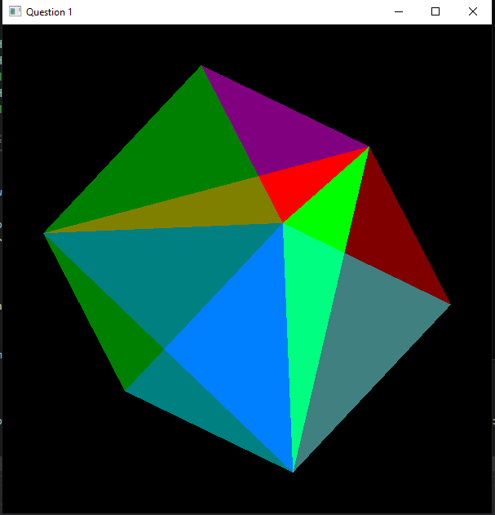

Each face of the cube was drawn with 2 triangles while the tetrahedron has 1 triangle on each face. Once a vertex of the cube is selected, the tetrahedron was drawn accordingly to the vertex. Each face of the cube and tetrahedron has different colour for better illustration.

# Question 2 – Surface subdivision

1. **Contributors:** Yunjie Bai and Kai Wey Lim

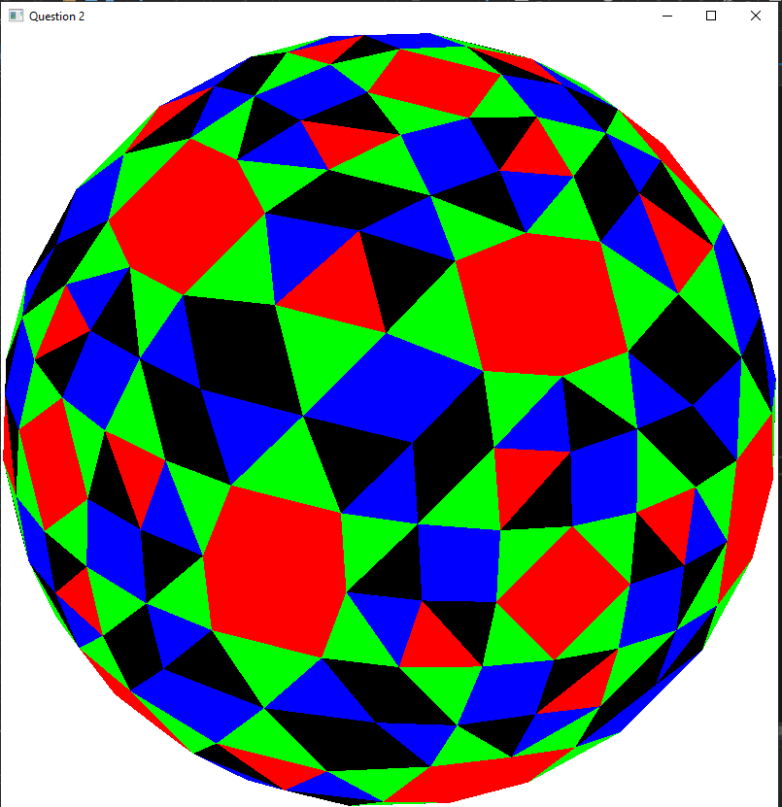

An octahedron was firstly constructed with eight triangles. After obtaining the coordinates of each triangle, the coordinates for each face are fed into a recursive function that will calculate the midpoint of each traingle’s vertices. Normalization is then carried out on the midpoints to push out the ‘4 th’ triangle. The recursion is then repeated based on the specified subdivision level. Each faces are also labelled to allocate their own color respectively.

# Question 3 – Transformation

1. **Contributors:** Yunjie Bai

